

**Polling District and Polling Place Review 2025**

**Walkergate Ward**

**Parliamentary Constituency:** East and Wallsend

**(Proposed) Polling Districts:** X01, X02, X03, X04, X05

The Local Government Boundary Commission for England are an independent body accountable to Parliament. They are responsible for reviewing councils to make sure their patterns of internal wards are fair and sensible. Their reviews include at least two rounds of public consultation before they make recommendations for change.

The final recommendations were published on 7 January 2025, and the new arrangements apply to local elections from 2026.

As a result of changes to ward boundaries the Acting Returning Officer (ARO) is conducting a review of polling districts and polling places to ensure that they are suitable for the new ward boundaries.

For more information on the local government boundary review visit: <https://www.lgbce.org.uk/all-reviews/newcastle-upon-tyne>

This document provides details of the review, along with the initial recommendations and comments of the Acting Returning Officer (ARO). Also, the election rules require the ARO to decide how many polling stations are required for each polling station and the ARO must allocate electors to the polling stations in such manner as they think most convenient.

These recommendations will be open to all residents, stakeholders, and any interested parties. We shall be seeking representations from local disability groups on the accessibility and suitability of polling places. Any comments should be addressed in the first instance to pollingplaces@newcastle.gov.uk where they will be collated on behalf of the (Acting) Returning Officer.

We considered the following factors:

* **Identifying new polling places:** We will look for new polling places in areas where the existing provision is unsuitable or unavailable.
* **Feedback:** We will consider feedback received following recent elections, consultation from members of the public, elected members, and other stakeholders.
* **Accessibility:** We will try to ensure that every polling place is accessible to electors with disabilities.
* **Facilities**: We will make sure that all electors have such reasonable facilities for voting as are practicable in the circumstances.
* **Elector numbers:** We will try to comply with the Electoral Commission guidance on the maximum number of electors that should be allocated to a polling station which should not exceed 2,250.
* **Future housing developments**: We will consider the impact of proposed housing developments on polling station electorates.

**(Current) Walkergate Ward**

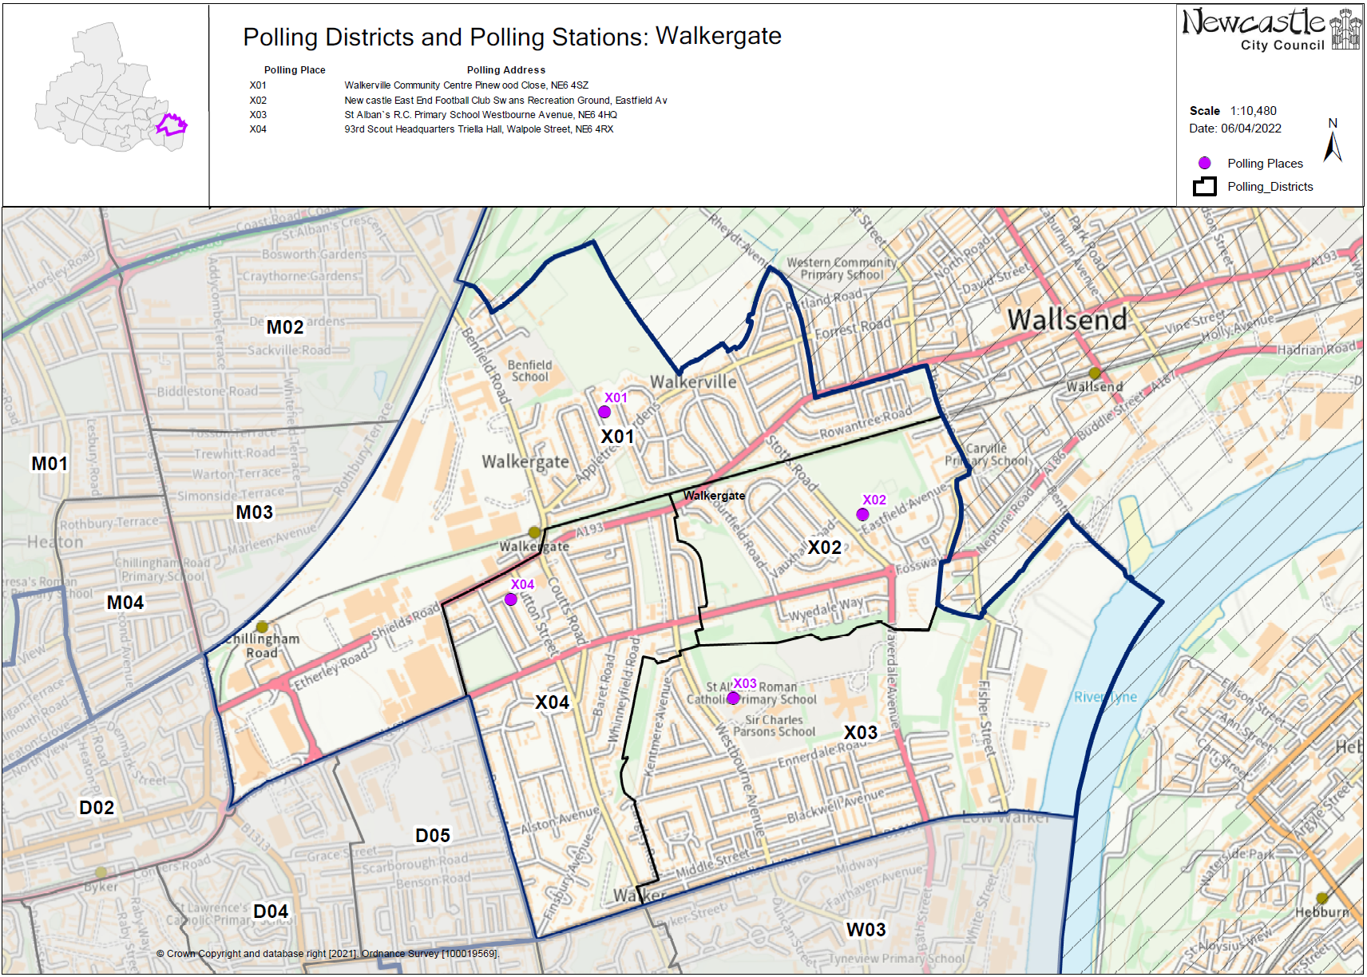This map shows the current ward and polling district boundaries and the polling places.

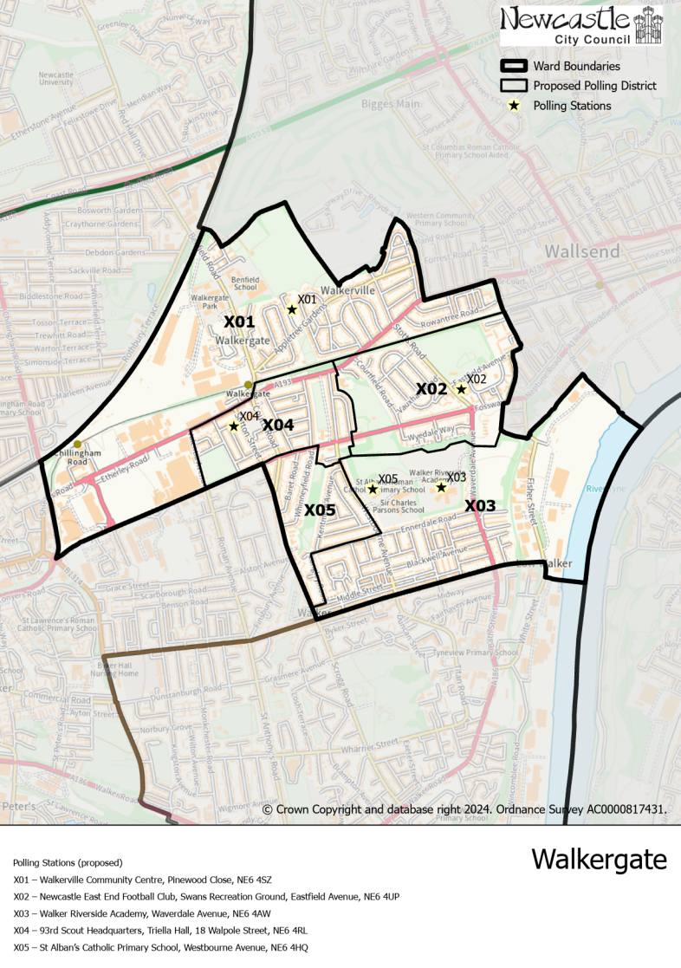**(New)**

**Walkergate Ward**

This map shows the new ward and the proposed polling districts and the proposed polling places.

* **X01**

Walkerville Community Centre, Pinewood Close, NE6 4SZ

* **X02**

Newcastle East End Football Club, Swans Recreation Ground, Eastfield Avenue, NE6 4UP

* **X03**

Walker Riverside Academy, Waverdale Avenue, NE6 4AW

* **X04**

93rd Scout Headquarters, Triella Hall, 18 Walpole Street, NE6 4RL

* **X05**

St Alban’s Catholic Primary School, Westbourne Avenue, NE6 4HQ

**Walkergate Ward**

**Polling District X01**

|  |  |
| --- | --- |
| **Current Polling District** | **Current Polling Place** |
| X01 (full) | Walkerville Community Centre, Pinewood Close, NE6 4SZ |

|  |  |  |
| --- | --- | --- |
| **Proposed Polling District** | **Predicted**  **Polling Station Electorate** | **Proposed Polling Place** |
| X01 | 1191 | Walkerville Community Centre, Pinewood Close, NE6 4SZ |

|  |
| --- |
| **Considerations and Proposals** |
| No change to the polling district boundary.  No change to the polling place. |

|  |
| --- |
| **Preliminary Consultation – Elected Members comments and feedback** |
| No comments received. |

**Walkergate Ward**

**Polling District X02**

|  |  |
| --- | --- |
| **Current Polling District** | **Current Polling Place** |
| X02 (full) | Newcastle East End Football Club, Swans Recreation Ground, Eastfield Avenue, NE6 4UP |

|  |  |  |
| --- | --- | --- |
| **Proposed**  **Polling District** | **Predicted**  **Polling Station Electorate** | **Proposed**  **Polling Place** |
| X02 | 891 | Newcastle East End Football Club, Swans Recreation Ground, Eastfield Avenue, NE6 4UP |

|  |
| --- |
| **Considerations and Proposals** |
| No changes to the polling district boundary.  No change to the polling place. |

|  |
| --- |
| **Preliminary Consultation – Elected Members comments and feedback** |
| No comments received. |

**Walkergate Ward**

**Polling District X03**

|  |  |
| --- | --- |
| **Current Polling District** | **Current Polling Place** |
| X03 (full)  W03 (Part of) | St Alban’s Catholic Primary School, Westbourne Avenue, NE6 4HQ  St Anthony of Padua Community Centre, Welbeck Road, NE6 3AB |

|  |  |  |
| --- | --- | --- |
| **Proposed Polling District** | **Predicted**  **Polling Station Electorate** | **Proposed Polling Place** |
| X03 | 1227 | Walker Riverside Academy, Waverdale Avenue, NE6 4AW |

|  |
| --- |
| **Considerations and Proposals** |
| Gains a small part of the current W03 district - part of unnamed road at the bottom of Welbeck Road, just off White Street. No residential properties appear to be affected. Loses some properties to the west of Westbourne Avenue.  Walker Riverside Academy is the suggested polling station for this district. A site visit has been carried out to confirm the suitability and that the site meets accessibility requirements. |

|  |
| --- |
| **Preliminary Consultation – Elected Members comments and feedback** |
| No comments received. |

**Walkergate Ward**

**Polling District X04**

|  |  |
| --- | --- |
| **Current Polling District** | **Current Polling Place** |
| X04 (part of) | 93rd Scout Headquarters, Triella Hall, 18 Walpole Street, NE6 4RL |

|  |  |  |
| --- | --- | --- |
| **Proposed Polling District** | **Predicted**  **Polling Station Electorate** | **Proposed Polling Place** |
| X04 | 724 | 93rd Scout Headquarters, Triella Hall, 18 Walpole Street, NE6 4RL |

|  |
| --- |
| **Considerations and Proposals** |
| Loses part of the polling district to Byker ward, south of the Fossway and west of Scrogg Road.  No change to the polling place. |

|  |
| --- |
| **Preliminary Consultation – Elected Members comments and feedback** |
| No comments received. |

**Walkergate Ward**

**Polling District X05**

|  |  |
| --- | --- |
| **Current Polling District** | **Current Polling Place** |
| X03 (part of)  X04 (part of) | St Alban’s Catholic Primary School, Westbourne Avenue, NE6 4HQ  93rd Scout Headquarters, Triella Hall, 18 Walpole Street, NE6 4RL |

|  |  |  |
| --- | --- | --- |
| **Proposed Polling District** | **Predicted**  **Polling Station Electorate** | **Proposed Polling Place** |
| X05 | 525 | St Alban’s Catholic Primary School, Westbourne Avenue, NE6 4HQ |

|  |
| --- |
| **Considerations and Proposals** |
| Part of the current X03 and X04 districts would merge to form the proposed X05 district. This would be a new district, incorporating part of the current X04 district, south of the Fossway and part of current X03 to the west of Westbourne Avenue.  St Alban’s Catholic Primary School is located in the proposed X03 district but is best situated to serve this district. |

|  |
| --- |
| **Preliminary Consultation – Elected Members comments and feedback** |
| No comments received. |